GENERAL INVESTMENT GROUP LTD

.CERTIFICATE OF AUTHENTICITY

Artist: PABLO PICASSO (1881-1973)

Title : La Corrida

Medium : Color Aquatint

Paper Size : 485x655 mm;
19 1/8 x 25 3/4 inches

Year : 1956

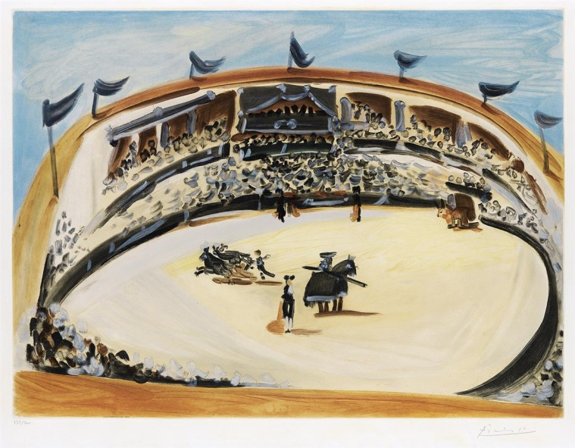

We hereby certify that the artwork mentioned above is an original Color Aquatint,1956. 19 1/8 x 25 ¾ inches, full margins.
Signed and numbered 137/200 in pencil, lower margin. Printed by Crommelynck, Paris, with the blind stamp lower left.
A very good, richly-inked impression of this large aquatint with strong colors.

Rami Ron
International Art Advisor/Lecturer

14620 Keswick Street, Van Nuys, CA 91405 Tel: 818-912 2654 Email:artsmrt@aol.com

